BLM tests in CNRAD 2009
One BLMI chamber was placed in to the CNRAD test area during the 2009 run of CNGS. The chamber was used as a reference input for the test of a BLM front end card (BLECF), which was placed in the same area
Radiation environment:
Primary SPS beam at 400GeV hits the graphite target. There are 2 extractions on CNGS target separated by 50ms, each with 10.5us length. Cycle repeats every ~6seconds. Test area is in a far end of the transverse shower several meters downstream and beside the reflector, which is the main source of radiation close to the lateral duct with test setup.
Remark: there is a 6s fixed offset between the BLM data and the TT41 BCT as a test crate was used on the BLM side.
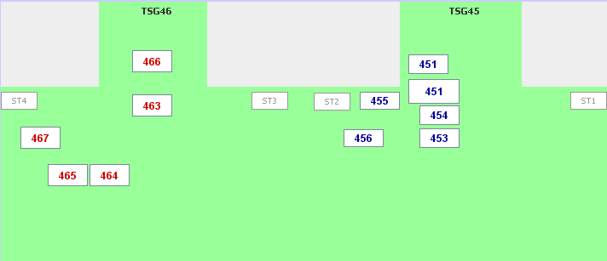
  - Area 451
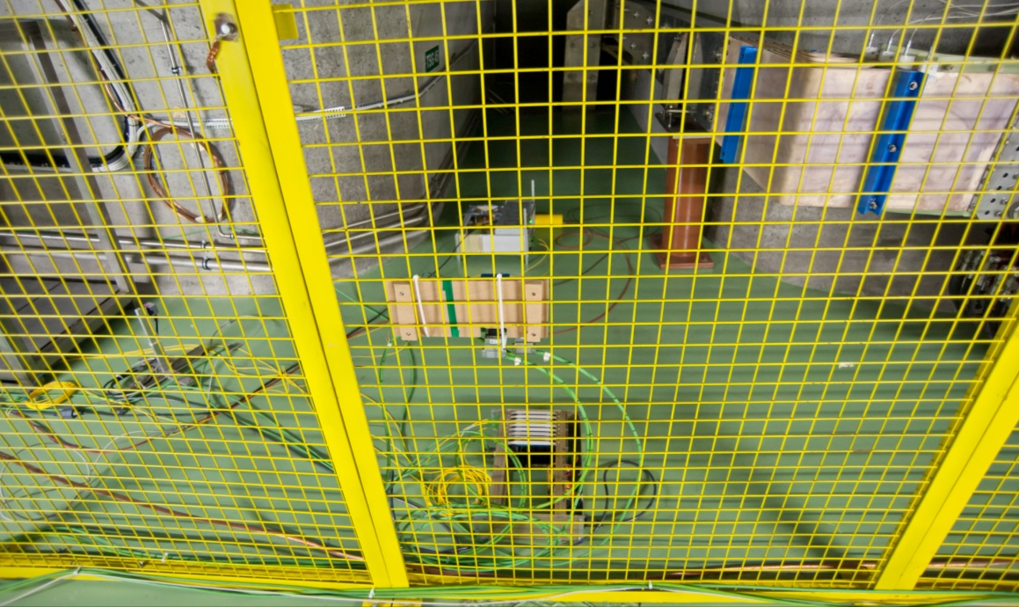
The area is calibrated with RadFets to 2.84 10⁻¹⁷Gy(Si)/pot and 2.0 10⁻⁷cm⁻²/pot for high energy hadrons. The value simulated by the FLUKA code inside a model of BLMI ionization chamber is 5.84 10⁻¹⁷ Gy(N₂)/pot.
When 3 days of measurement data are integrated, the following doses are obtained depending on the running sum used.
Data range: | 1 Sept 1:55 – 3 Sept 4:22 | dD/dI [Gy(N₂)/pot]
Protons on target | 5.285 10¹⁷pot
∫D_{RS01} [Gy(N₂)] | 7.13 | 1.35 10⁻¹⁷
∫D_{RS03} [Gy(N₂)] | 14.3 | 2.71 10⁻¹⁷
∫D_{RS04} [Gy(N₂)] | 14.8 | 2.80 10⁻¹⁷
∫D_{RS09} [Gy(N₂)] | 32.0 | 6.05 10⁻¹⁷

The short running sums show only the peak value of the sum during the last second, whereas the RS09 shows the actual value for the last 1.3 seconds (logging rate is 1Hz). Only one of the two extractions is then measured due to this fact for the short running sums. Both pulses are integrated from RS07 (82ms) onwards.
When one looks only at one extraction pair, the following dose rates and the corresponding integrated doses are obtained:
Timestamp (local time) |  | 1 Sept 2009 15:50:41
Int EXTR1 |  | 1.98 10¹³pot
Int EXTR2 |  | 2.14 10¹³pot
 | RS window | Max dD_{RS0X}/dt [Gy(N₂)/s] | ∫D_{RS0X} [mGy(N₂)] | dD/dI [Gy/pot]
RS01 | 40u | 13.9 | 0.554 | 2.60 10⁻¹⁷
RS02 | 80u | 8.39 | 0.671 | 3.14 10⁻¹⁷
RS03 | 320u | 2.98 | 0.954 | 4.46 10⁻¹⁷
RS04 | 640u | 1.54 | 0.986 | 4.61 10⁻¹⁷
RS05 | 2.56m | 0.394 | 1.009 | 4.71 10⁻¹⁷
RS06 | 10.24m | 0.1006 | 1.030 | 4.81 10⁻¹⁷
RS07 | 81.92m | 0.0243 | 1.99 | 4.83 10⁻¹⁷
RS08 | 655m | 0.003037 | 1.99 | 4.83 10⁻¹⁷
RS09 | 1.31s | 0.00152 | 1.99 | 4.83 10⁻¹⁷

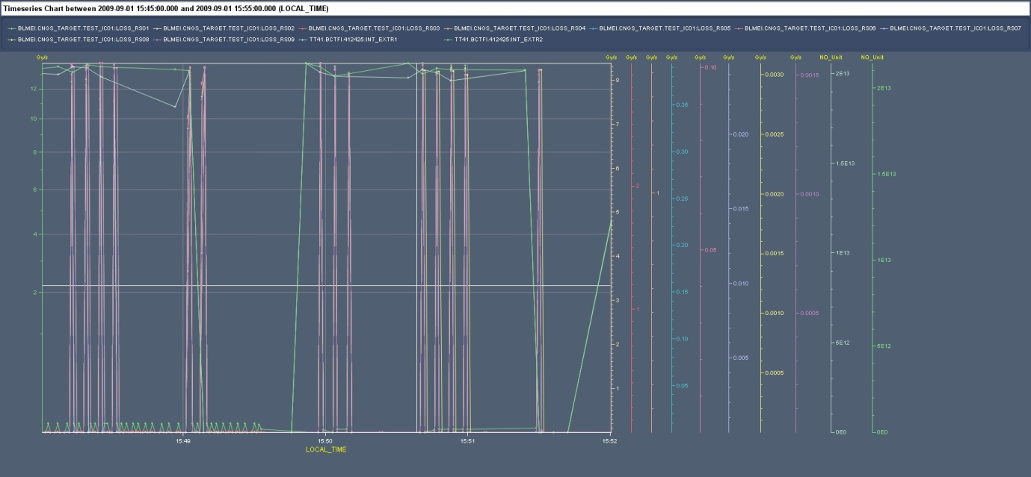
Figure 1: Area 451 - BLM data and BCT values for 2 TT41 extractions. The data sets have 6s offset.
  - Area 455
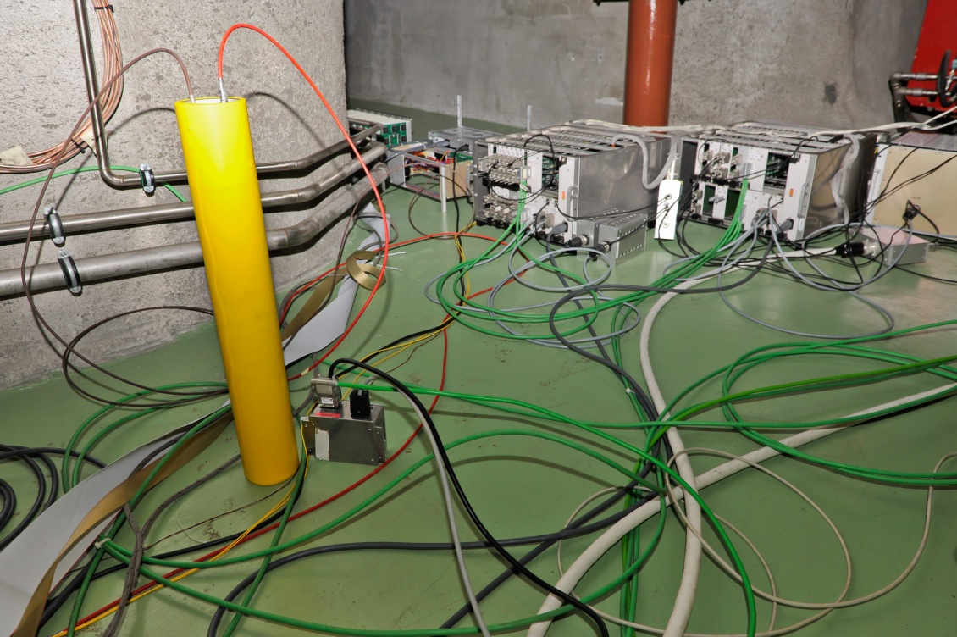
The area is calibrated with RadFets to 1.38 10⁻¹⁸Gy(Si)/pot and 4.30 10⁻⁹cm⁻²/pot for high energy hadrons. The value simulated by the FLUKA code inside a model of BLMI ionization chamber is 1.8 10⁻¹⁸ Gy(N₂)/pot. The simulated value for dose in Air is 2.1 10⁻¹⁸Gy(Air)/pot.
Data range: | 23 Sept 17:40 – 24 Sept 10:30 | dD/dI [Gy(N₂)/pot]
Protons on target | 2.032 10¹⁷pot
∫D_{RS01} [Gy(N₂)] | 0.0367 | 1.81 10⁻¹⁹
∫D_{RS03} [Gy(N₂)] | 0.0735 | 3.62 10⁻¹⁹
∫D_{RS04} [Gy(N₂)] | 0.0805 | 3.96 10⁻¹⁹
∫D_{RS09} [Gy(N₂)] | 0.273 | 1.34 10⁻¹⁸

Noise level for the RS01 is 0.015Gy/s. This makes with 33690 retrieved values 0.020Gy, which is 55% of the integral at 40us. Some of the values from RS09 can appear for two consecutive logging timestamps and therefore increase the total integral.
When one looks only at one extraction pair, the following dose rates and the corresponding integrated doses are obtained:
Timestamp (local time) |  | 24 Sept 2009 9:01:29
Int EXTR1 |  | 2.01 10¹³pot
Int EXTR2 |  | 2.02 10¹³pot
 | RS window | Max dD_{RS0X}/dt [Gy(N₂)/s] | ∫D_{RS0X} [Gy(N₂)] | dD/dI [Gy/pot]
RS01 | 40u | 0.146 | 5.84 10⁻⁶ | 2.9 10⁻¹⁹
RS02 | 80u | 0.0877 | 7.02 10⁻⁶ | 3.5 10⁻¹⁹
RS03 | 320u | 0.0358 | 1.15 10⁻⁵ | 5.7 10⁻¹⁹
RS04 | 640u | 0.0196 | 1.25 10⁻⁵ | 6.2 10⁻¹⁹
RS05 | 2.56m | 0.00607 | 1.55 10⁻⁵ | 7.7 10⁻¹⁹
RS06 | 10.24m | 0.00195 | 2.00 10⁻⁵ | 9.9 10⁻¹⁹
RS07 | 81.92m | 5.15 10⁻⁴ | 4.22 10⁻⁵ | 1.0 10⁻¹⁸
RS08 | 655m | 6.46 10⁻⁵ | 4.23 10⁻⁵ | 1.0 10⁻¹⁸
RS09 | 1.3s | 3.24 10⁻⁵ | 4.21 10⁻⁵ | 1.0 10⁻¹⁸

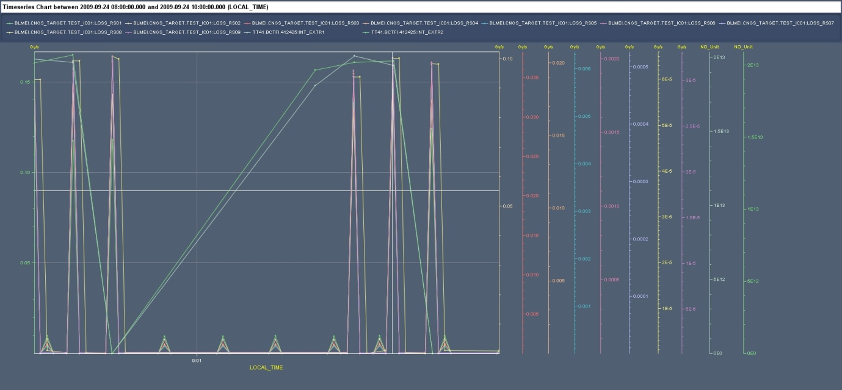
Figure 2: Area 455 - BLM data and BCT values for 2 TT41 extractions. The data sets have 6s offset.
One can see a regular noise pattern on Fig. 2. This noise is not correlated to the beam extractions and its source has not been identified yet. It certainly contributes to the difference between the single shot and continuous integration.

Conclusions
The dose calibration obtained by the BLMI chamber has to be calculated taking into account the double pulse extraction from SPS. The difference between the calibration obtained by integration of the signal for several days and a single pulse analysis is between 20 and 25%. The difference is likely caused by noise and offset current.
The measured dose in the area 451 is lower than the FLUKA estimation by 17%. The simulation including the BLMI model in the area 455 is so far missing. The difference between the measured dose from the BLM and the dose measured by RadFet is 28% in case of the area 455, where the RadFet measures higher dose. This difference is 41% in case of the area 451, where the RadFet measures lower dose.
The dose measured by the BLMI and normalized by beam intensity assuming 20% error is
- 4.8 ± 0.9 10⁻¹⁷ Gy(N₂)/pot for area 451
- 1.0 ± 0.2 10⁻¹⁸ Gy(N₂)/pot for area 455
The contribution of thermal neutrons to the BLM signal has not been studied in detail as the simulation data has yet to be completed.
The peak dose rate inside the BLM was calculated using the known extraction length and no recombination correction was applied.
Table 1: Summary table
Test area | 451 | 455
BLM measurement | 4.8 ± 0.9 10⁻¹⁷ Gy(N₂)/pot | 1.0 ± 0.2 10⁻¹⁸ Gy(N₂)/pot
FLUKA dose in BLM | 5.8 ± 0.3 10⁻¹⁷ Gy(N₂)/pot | 1.8 ± 0.1 10⁻¹⁸ Gy(N₂)/pot
FLUKA dose in Air | 4.2 ± 0.2 10⁻¹⁷ Gy(Air)/pot | 2.1 ± 0.3 10⁻¹⁸ Gy(Air)/pot
Measured dose in Silicon | 2.8 ± 0.8 10⁻¹⁷ Gy(Si)/pot | 1.4 ± 0.4 10⁻¹⁸ Gy(Si)/pot
Peak dose rate in BLM (10.5us) | 95 Gy(N₂)/s | 1.2 Gy(N₂)/s

