Group Code.: AB-BDI
EDMS No.: | Original: English
The Large Hadron Collider Project

Technical Specification

for the supplying of the photodiodes receivers of the LHC beam loss monitors optical link

Abstract
The Beam Loss Monitoring System in the LHC uses an optical link between the radioactive area (in the tunnel) and the surface where the data processing is done. This technical specification defines the requirement for the optical receivers of this data link on the surface.

Table of Contents
1. INTRODUCTION 1
1.1 Introduction to CERN 1
1.2 Introduction to the LHC Project 1
2. scope of thE technical Specification 1
2.1 Scope of the supply 1
general conditions for tendering and contracting 2
2.2 Tender procedure 2
2.2.1 Pre-tender discussions 2
2.2.2 Preliminary programme 2
2.2.3 Subcontractors 2
2.2.4 Country of origin 2
2.3 Contract execution 2
2.3.1 Responsibility for design, components and performance 2
2.3.2 Assembly equipments 2
2.3.3 Contract follow-up 3
2.3.4 Deviations from the Technical Specification 3
3. Technical requirements 4
3.1 General description 4
3.2 Dimensions and tolerances 4
3.3 Performance 5
3.4 Operational conditions 5
3.5 Information and documentation management 6
3.5.1 Planning and scheduling 6
3.5.2 Delivery schedule 6
4. applicable documents 6
5. delivery and commissioning 6
5.1 Packing and transport to CERN 6
5.2 Acceptance and guarantee 6
6. cern contact PERSONS 7

Term | Definition
CDD | CERN Drawing Directory
EDMS | Engineering Data Management System
QAP | Quality Assurance Plan

INTRODUCTION

Introduction to CERN
The European Organization for Nuclear Research (CERN) is an intergovernmental organization with 20 Member States*. It has its seat in Geneva but straddles the Swiss-French border. Its objective is to provide for collaboration among European States in the field of high energy particle physics research and to this end it designs, constructs and runs the necessary particle accelerators and the associated experimental areas.
At present more than 5000 physicists from research institutes world-wide use the CERN installations for their experiments.

Introduction to the LHC Project
The Large Hadron Collider (LHC) is the next accelerator being constructed on the CERN site. The LHC machine will mainly accelerate and collide 7 TeV proton beams but also heavier ions up to lead. It will be installed in the existing 27 km circumference tunnel, about 100 m underground, that previously housed the Large Electron Positron Collider (LEP). The LHC design is based on superconducting twin-aperture magnets which operate in a superfluid helium bath at 1.9 K.

scope of thE technical Specification

The Beam Loss Monitoring System in the LHC uses an optical link between the radioactive area (the tunnel) and the surface where the data processing is done. This technical specification defines the technical requirement for the optical receivers of this data link on the surface.

Scope of the supply

The scope of this piece inquiry includes:
- The supply of 1460 photodiode receivers.
- The supply and the assembly of the E2000/APC connectors for the 1460 photodiodes.

general conditions for tendering and contracting
Please refer to the commercial documents for more complete information.

Tender procedure

Pre-tender discussions
The Bidder is strongly encouraged to contact CERN and discuss details of the Technical Specification before submitting a tender. In particular, CERN wishes to ensure that no doubt exists as to the interpretation of the Technical Specification.

Preliminary programme
The Bidder shall propose a preliminary design and manufacturing schedule with the tender, based on the specified CERN provisional delivery schedule.

Subcontractors
The Bidder shall declare in his Tender any subcontractors whose services he intends to use in the event of a Contract. Refer to the commercial documents for more details. If awarded the Contract, the Bidder shall restrict himself both to the subcontractors and the amount mentioned in the Tender. If, for some reason, he wants to change any subcontractor, or the scope of subcontracted work, or the amount subcontracted, he must obtain CERN’s prior agreement in writing.

Country of origin
Please refer to the commercial documents for specific conditions concerning the country of origin of the equipment or services to be supplied.

Contract execution

Responsibility for design, components and performance
The Contractor shall be responsible for the correct performance of all items supplied, irrespective of whether they have been chosen by the Contractor or suggested by CERN. CERN's approval of the design and component choice does not release the Contractor from his responsibilities in this respect.
CERN assumes responsibility for the performance of items and sub-systems supplied by CERN.
CERN reserves the right to make minor modifications to the specification before placing the contract. These minor changes must not affect the contractual price that shall remain fixed.

Assembly equipments
The Contractor is responsible for the parts assembly defined in the contract including all the specific equipments and material for the execution of the work.

Contract follow-up

Contract engineer
The Contractor shall assign an engineer to be responsible for the technical execution of the Contract and its follow-up throughout the duration of the Contract.

Deviations from the Technical Specification
If, after the Contract is placed, the Contractor discovers that he has misinterpreted the Technical Specification, this will not be accepted as an excuse for deviation from it and the Contractor shall deliver equipment in conformity with the Technical Specification at no extra cost.
During execution of the Contract, all deviations proposed by the Contractor from the Technical Specification, the Tender, or any other subsequent contractual agreement, shall be submitted to CERN in writing. CERN reserves the right to reject or accept such proposals without justification.
CERN reserves the right to modify the Technical Specification during execution of the Contract. The consequences of such modifications shall be mutually agreed between CERN and the Contractor.

Technical requirements

General description
The receivers are based on photodiode “PIN“with transimpedance amplifier and differential output for a minimum reception speed of 800 Mbps with single mode fibre. The package is a coaxial pigtailed housing. The purpose of this receiver is data communications.

Dimensions and tolerances

The general aspect of the part must meet the drawing below. The mandatory dimensions are:
- The height of the case.
- The length of the device without output pins.
- The distance between the 2 holes and the size of it (made for an M2 screw).
The other dimensions can be relaxed in reasonable proportions and will be studied by the technical contact before approval.

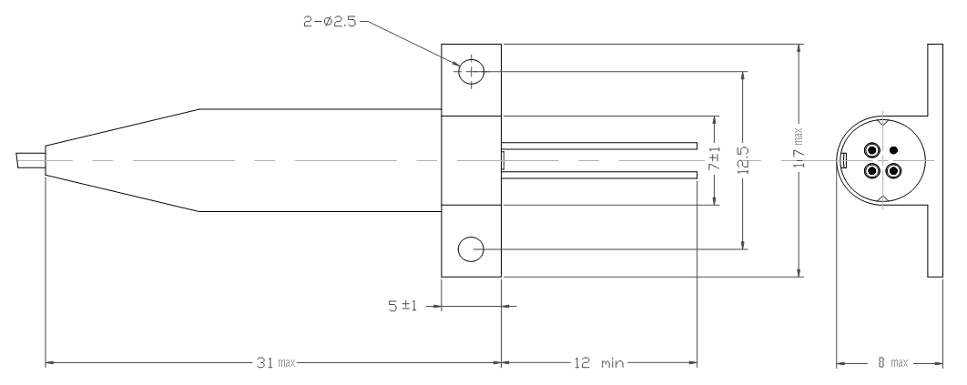

Performance

The performance requirements are shown below:

Parameter |  | Min. | Typ. | Max. | Unit
Supply voltage | Vcc |  | 3.3 |  | V
Sensitivity | S |  |  | -21 | dBm
wavelength | λ |  | 1310 |  | nm
link speed |  | 800 |  |  | Mbps

Case type: PIN Pigtailed
Fibre type: Single mode (9/125/250)
Connector type: E2000/APC
Output type: Differential

Pinout:
D -
GND
Vcc
D +

Bottom view of the case

Operational conditions
Operating condition: commercial grade -40˚C +85˚C

Information and documentation management

Planning and scheduling
The contractor is responsible for the detailed scheduling of the assembly work of the different parts of the device to meet the delivery schedule.

Delivery schedule
The contractor should be able to supply the devices according to the schedule below:

12.2005 | 03.2006 | 05.2006 | 07.2006
200 | 400 | 400 | 460

In case if the contractor can supply the devices faster, the CERN will accept earlier delivery.

applicable documents
Please refer to the cover letter or Instructions to Bidders for the complete list of enclosed documents which form part of this Invitation to Tender.

delivery and commissioning

Packing and transport to CERN
The Contractor is responsible for the packing and, where included, the transport to CERN. He shall ensure that the equipment is delivered to CERN without damage and any possible deterioration in performance due to transport conditions.

Acceptance and guarantee
Provisional acceptance will be given by CERN only after all items have been delivered in accordance with the conditions of the contract including documentation referred to in the Technical Specification, all tests specified have been successfully completed and all test or other certificates have been supplied to CERN.
The guarantee period is defined in the commercial documents.

cern contact PERSONS
Persons to be contacted for technical matters:
Name/Division/Group | Tel-Fax | Email
Jonathan Emery AB/BDI | Tel: +41 22 76 70239 | Jonathan.Emery@cern.ch
Jonathan Emery AB/BDI | Fax: +41 22 76 79560 | Jonathan.Emery@cern.ch
In case of absence:  Christos Zamantzas AB/BDI | Tel: +41 22 76 73409 | Christos.Zamantzas@cern.ch
In case of absence:  Christos Zamantzas AB/BDI | Fax: +41 22 76 79560 | Christos.Zamantzas@cern.ch

Persons to be contacted for commercial matters:
Name/Division/Group | Tel-Fax | Email
Karine Robert FI/LS | Tel: +41 22 76 74407 | Karine.Robert@cern.ch
Karine Robert FI/LS | Fax: +41 22 76 7 | Karine.Robert@cern.ch
In case of absence:  Isabelle Mardirossian FI/LS | Tel: +41 22 76 78459 | Isabelle.Mardirossian@cern.ch
In case of absence:  Isabelle Mardirossian FI/LS | Fax: +41 22 76 7 | Isabelle.Mardirossian@cern.ch

* CERN Member States are: Austria, Belgium, Bulgaria, Czech Republic, Denmark, Finland, France, Germany, Greece, Hungary, Italy, The Netherlands, Norway, Poland, Portugal, Slovak Republic, Spain, Sweden, Switzerland and the United Kingdom.

