1.25Gbps Pigtailed Coaxial PIN-TIA PD (3.3V)
NTPPT-3EP-x-x

Features



InGaAs long wavelength PIN photodiode with trans-impedance amplifier and decoupling capacitor
High sensitivity with AGC
Single +3.3V power supply
Differential output
Operating temperature from -40 to + 85℃
Single-mode fiber pigtailed with SC,FC connectors

Description
The NTPPT-3 series consist of a reliable InGaAs PIN photodiode with transimpedance amplifier and decoupling capacitor. The NTPPT-3 series are suitable for receiving the light having a wavelength range of 1000 to 1650nm. This photodiode features high quantum efficiency, low dark current and low capacitance for high speed optical fiber communications.

Applications
For telecommunication and data communication systems, from medium to high speed for intra-office, short-haul inter-office and long-haul inter-office applications.
155Mbps, 622Mbps SONET/SDH Receiver
1.25Gbps Gigabit Ethernet Receiver
FTTH, fast Ethernet Receiver
Absolute Maximum Ratings
Parameter | Symbol | Min. | Typ. | Max. | Unit | Condition
Supply Voltage | Vcc |  |  | 4 | V
Optical Input Power | Pin |  |  | 2 | dBm
Operating Temperature | Top | -40 |  | +85 | ℃
Storage Temperature | Tstg | -40 |  | +85 | ℃

Electrical and Optical Characteristics
(Vcc=+3.3V, T_{C}=25℃)
Parameter | Symbol | Min. | Typ. | Max. | Unit | Condition
Supply Voltage | Vcc | 3 | 3.3 | 3.6 | V
Supply Current Note | Icc |  | 30 | 42 | mA
Detection Range | λ | 1.0 |  | 1.65 | ㎛
Gain | G | - | 8 | - | V/mW | Differential
Bandwidth Note | BW | 830 | - | - | MHz | -3dB
Saturation Power | Psat | 0 | - | - | dBm | λ=1.3㎛
Sensitivity | S | - | -25 | -23 | dBm | BER=10⁻¹²  @1.25Gbps
Output Resistance | Rout | - | 50 | - | Ω

Outline Diagram
Horizontal Flange
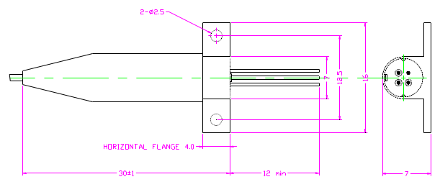
1
2
3
4
Bottom View

Vertical Flange
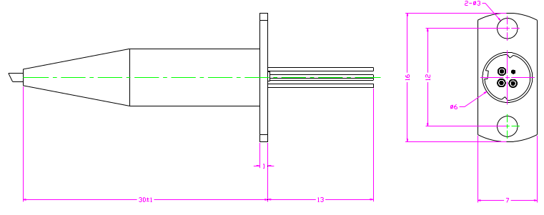
1
2
3
4
Bottom View

Pin Description
1: GND(Case)
2: Vcc
3: Vo
4: Vo
1
2
3
4
Bottom View
TIA
1
GND(Case)
0.5nF
PD
Vcc
2
4
Vo
3
Vo

Ordering Information
P:PIN
P: Pigtailed PD
R: Receptacle PD
N:No Connector
1:SC/PC
2:SC/APC
3:FC/PC
4:FC/APC
N: No Flange
V: Vertical
H: Horizontal
T: With TIA
P
NT
P
1:155M, 4:622M, E:1.25G
3: 3.3V, 5: 5V

T
P:PD
NT:NEOPTEK

