Electron pairs, per proton, per litre. Horizontal cross sectional view at beam height. Scales are in cm. The beam comes from the left side.
The collimator is at point x=0 cm.

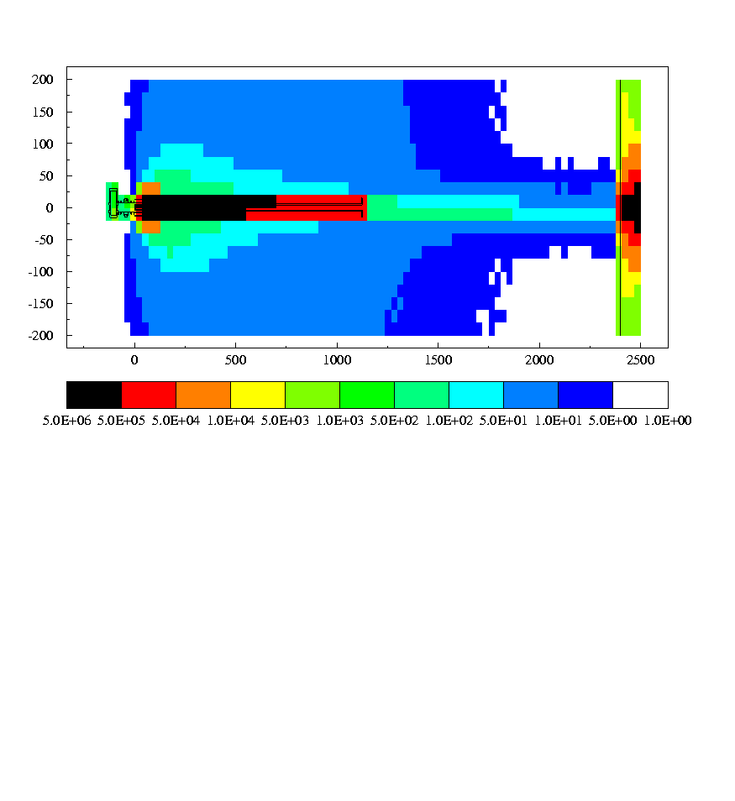

Electron pairs, per proton, per litre. Vertical cross sectional view. Scales are in cm. The beam comes from the left side.
The collimator is at point x=0 cm

